ME 4053: Fall 2025

Project 2

Wind Turbine Analysis

M. Anderson & E. Severson

Mechanical Engineering Department

University of Minnesota

October 14th, 2025

As the theme for this modeling course this term is energy conversion and storage, this project analyzes the 2.5 MW University of Minnesota wind turbine located in Rosemount Minnesota. The goal is to understand and model various mechanical components of this turbine.

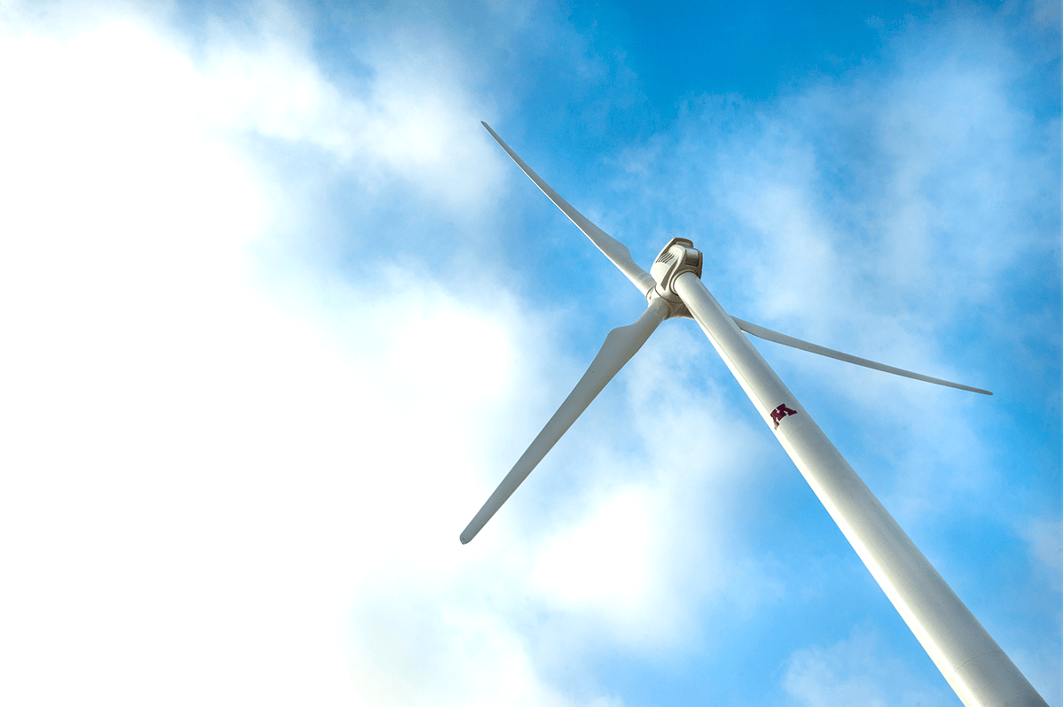

**Figure 1:** UMN Clipper 2.5 MW wind turbine

Your task is to determine what information and background is necessary to answer the questions outlined in the Deliverables section. The report is expected to be similar in depth, length and format to that of Project 1 but in contrast to that project all materials/theory will not be provided in this initial project document. Teams are expected to begin developing their own model and determine what additional information is needed in order to thoroughly answer the questions described in Section 2.

Appendices will be added to this document as the project develops based on the class’s requests for additional information/specifications.

# The Wind Turbine

The turbine that is to be analyzed is a Clipper Liberty C96 2.5 MW wind turbine located in Rosemount, MN. The basic specifications of the C96 turbine are given in Table 1. This is a 3-blade, upwind turbine that is pitch controlled and variable speed. It has a yaw control and for this analysis the yaw angle will be set to 0°.

**Table 1:** Properties of the UMN Clipper C96 Wind Turbine

| **Parameter** | **Value** |
| --- | --- |
| Rated Power | 2.5 [MW] |
| Blade/Rotor Radius | 48 [m] |
| Hub Height | 80.4 [m] |
| Cut-In Speed | 4 [m/s] |
| Rated Speed | 11 [m/s] |
| Cut-Out Speed | 25 [m/s] |
| Rotor Speed | 9.6 - 15.5 [RPM] |

# The Deliverables

For the C96 wind turbine, determine the following:

1. For a wind velocity of 10 [m/s], a rotational velocity of 14 [rpm] and 0 [deg] pitch angle, determine:
   1. The coefficient of power, $C_{P}$
   2. The coefficient of thrust, $C_{T}$
2. Sweep the blade pitch angle to determine the maximum CP for a specific wind velocity and tip speed ratio. Each group will have different conditions that will be found on the course CANVAS page.
3. Sweep both the blade pitch angle and the tip speed ratio to determine the maximum CP for a specific wind velocity. Each group will have different conditions that will be found on the course CANVAS page.
4. Determine the blade pitch necessary in order to make sure not to over power the turbine between the rated and cut-out speed. Again, each group will have a different wind velocity, found on the course CANVAS page, but all analyses will be completed at the maximum rotational velocity.
5. Perform a structural analysis of the wind turbine tower for the loading conditions assigned to your group in Item #4.

# The Report

The calculations and conclusions from the deliverables section should be documented with an engineering report. Each report should take the form of an “executive summary”. Completeness, clarity and conciseness are all far more important than length. Something on the order of 6-8 pages in length is probably reasonable, the report is limited to 10 pages. The report should meet professional standards, with no grammar or spelling errors. As this project is more open-ended with regard to the analytical/numerical methods used, it is expected that a discussion of the assumptions (and their limitations) be included in this report.

The report should include an introduction paragraph that enables the reader to understand what the report is about, and that briefly describes the contents of the report. The report should include a conclusions paragraph that reviews the key findings of your analyses both qualitatively and quantitatively.

A Gradescope portal will be provided for this report. The MATLAB code developed and used for this project will be submitted to a separate Gradescope portal. Since we will have your code, you do not need to include a listing of the MATLAB code in the report. However, any figures used in the report should be generated via the submitted MATLAB code.